**“AITor” - EDUCATION PLATFORM – A PERSONALIZED STUDENT PERFORMANCE ANALYZER AND RECOMMENDATION SYSTEM**

2022-017

Project Status Document - 2

Liyanage N.L.T.N - IT19188546

B.Sc. (Hons) in Information Technology specializing in Software Engineering

Department of Software Engineering

Sri Lanka Institute of Information Technology

Sri Lanka

January 2022

# DECLARATION

We declare that this is our own work, and this proposal does not incorporate without acknowledgement any material previously submitted for a degree or diploma in any other university or Institute of higher learning and to the best of our knowledge and belief it does not contain any material previously published or written by another person except where the acknowledgement is made in the text.

|  |  |  |
| --- | --- | --- |
| Name | Student ID | Signature |
| Liyanage N.L.T.N | IT19188546 |  |

The above candidates are carrying out research for the undergraduate Dissertation

under my supervision.

Date:

11/13/2022

Contents

DECLARATION ii

1. Microsoft Teams chats and Meetings with supervisor/co-supervisor/external supervisor 5

Initial Teams group for research team – continuous communication 5

1.1. Research team members only MS teams’ continuous communication 6

2. WhatsApp Chat Group for Continuous Communication with Team Members with Supervisor/Co-Supervisor/External Supervisor. 8

2.1. Continuous Commination through WhatsApp Chat Group 8

3. Scheduled MS Teams discussions 15

3.1. Weekly meeting with team members 15

3.2. Bi-Weekly meeting with Co-Supervisor/External-Supervisor for research progress evaluation 16

4. Research Paper Presentations 18

4.1. IEEE UEMCON 2022 18

5. Project planner 20

5.1. Boards 20

5.2. Charts 22

5.2.1. Overall Project Task Overview 22

5.2.2. Overview of Tasks Of Thammita D.H.M.M.P(IT19120362) 24

6. Project Gantt chart 25

7. Work breakdown chart 26

8. User task allocation details 26

Allocated task 27

Predicted time 27

Actual time spent 27

1. Key learning area Identifier Dataset creation 27

01/04/2022 – 30/04/2022 (30 days) 27

20 days 27

2. Learning area Identifier algorithm implementation 27

15/04/2022 – 30/04/2022 (15 days) 27

21 days 27

3. Learning area Identifier API implementation 27

01/05/2022 – 06/05/2022 (6 days) 27

1 day 27

4. Learning material recommender model implementation using cosine similarity 27

30/04/2022 – 11/05/2022 (11 days) 27

6 days 27

5. Key learning area dataset creation 27

05/04/2022 – 05/04/2022 (10 days) 27

10 days 27

6. Learning material recommender model - DAL integration 27

25/06/2022 – 30/06/2022 (5 days) 27

2 days 27

7. Learning material algorithm integration with learning style identifier module 27

30/06/2022 – 15/07/2022 (15 days) 27

12days 27

8. Learning material dataset collection and preprocessing 27

01/06/2022 – 01/07/2022 (30 days) 27

30 days 27

9. Learning material recommender algorithm evaluation 27

20/07/2022 – 31/07/2022 (21 days) 27

25 days 27

10. Frontend Implementation 28

15/07/2022 – 30/08/2022 (45 days) 28

40 days 28

11. Key learning area identifier model testing 28

15/08/2022 – 30/08/2022 (15 days) 28

16 Days 28

12. Overall System Integration 28

01/09/2022 – 20/09/2022 (20 days) 28

30 days 28

9. GitLab Charts 28

9.1. Commits To Master Branch 28

9.2. Commits By Liyanage N.L.T.N. (IT19188546) 29

9.3. Commits To dev/it19188546 31

# Microsoft Teams chats and Meetings with supervisor/co-supervisor/external supervisor

## Initial Teams group for research team – continuous communication

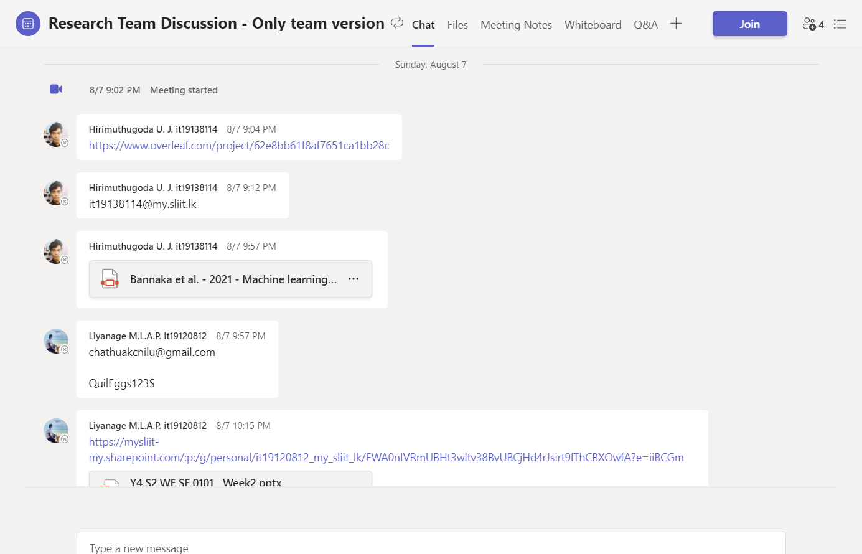

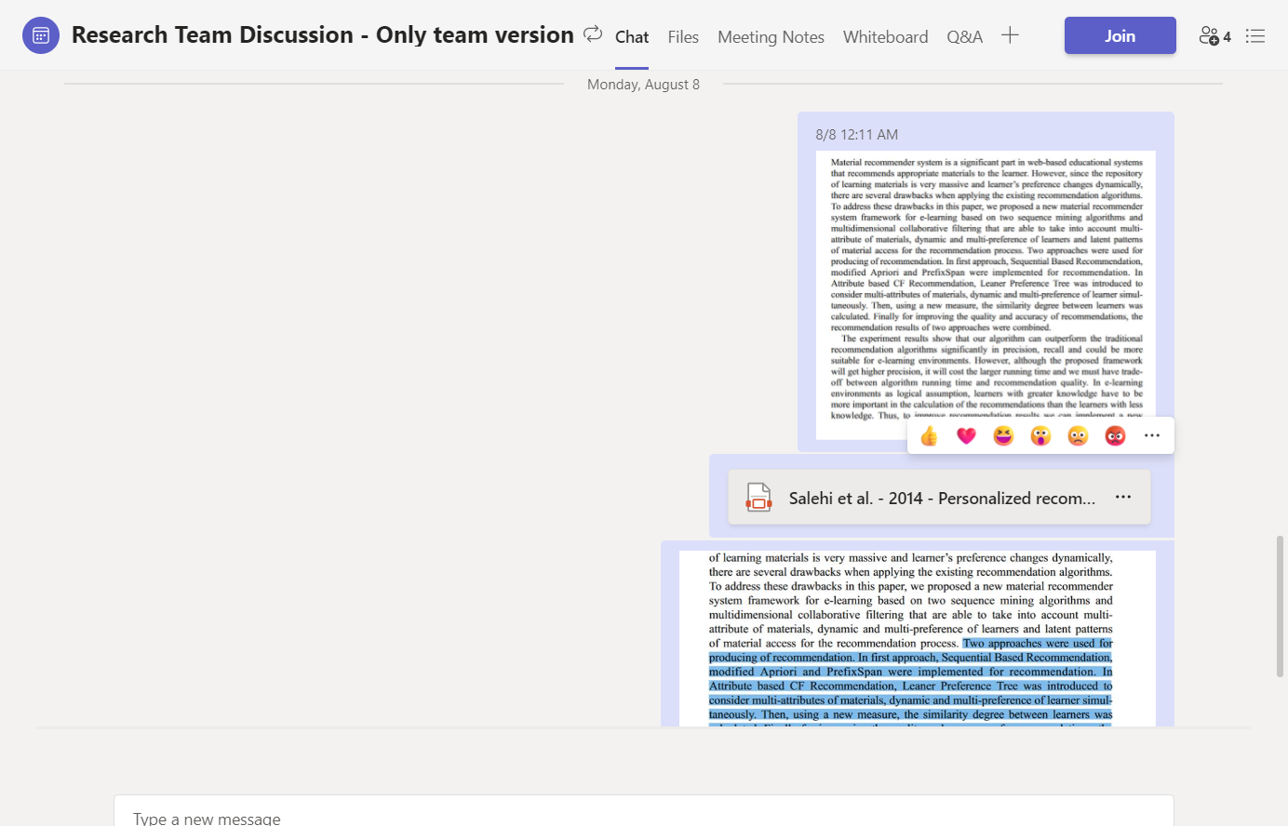

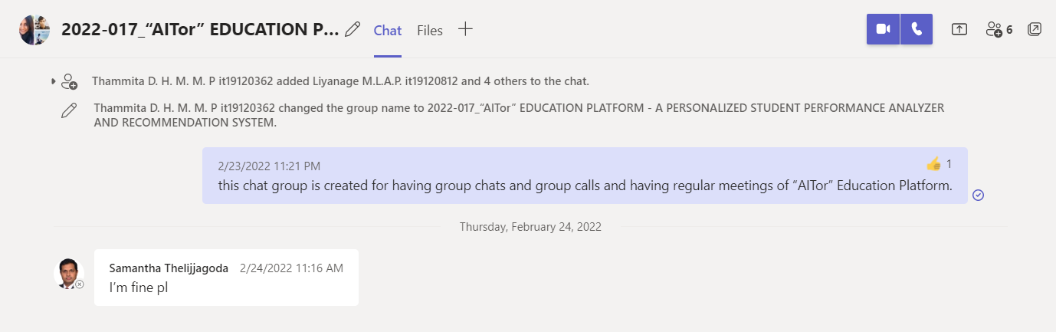

Figure :: Microsoft Teams , Team Creation for meetings with Supervisor/Co-Supervisor/External Supervisors

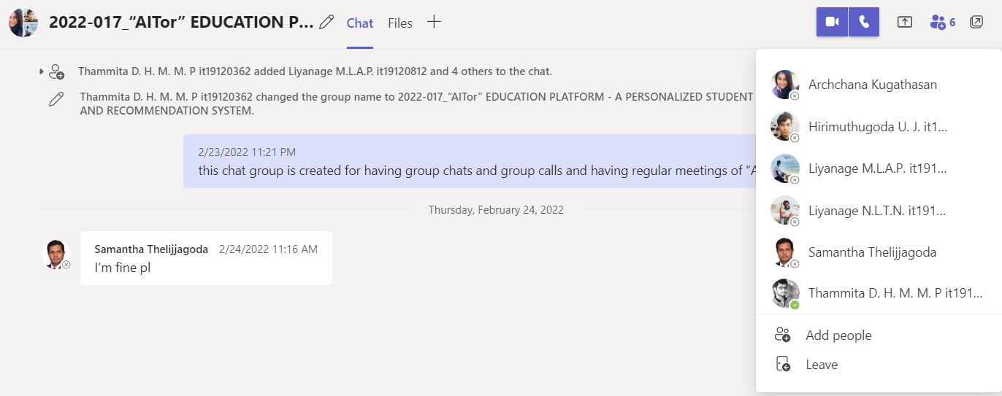

## Research team members only MS teams’ continuous communication

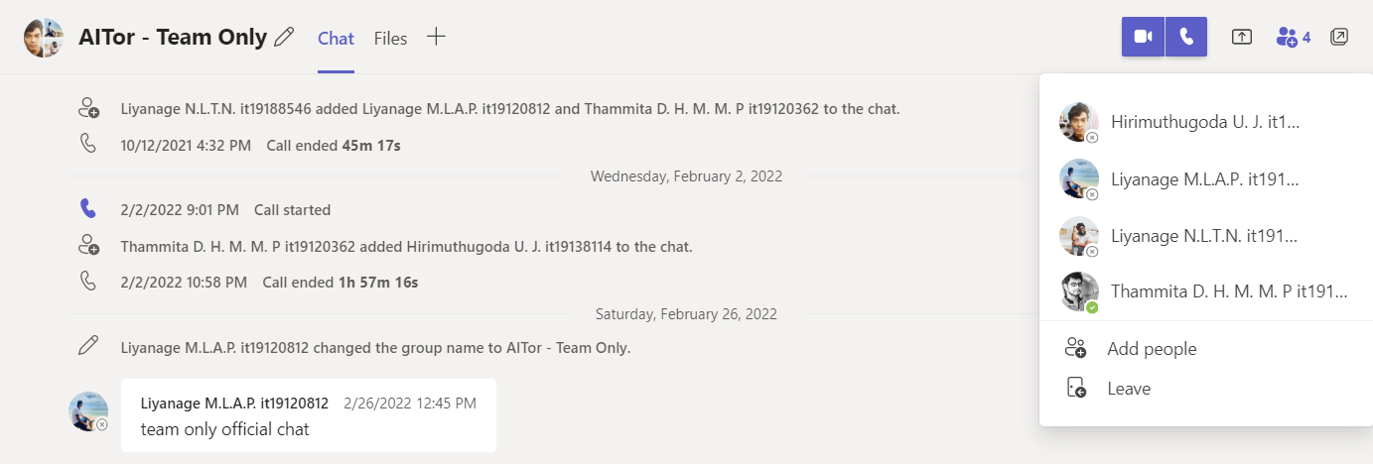

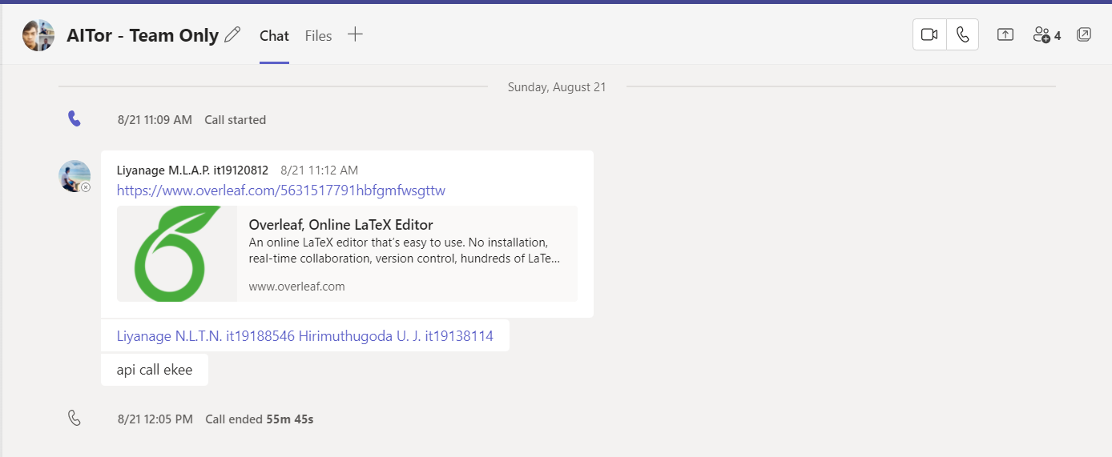

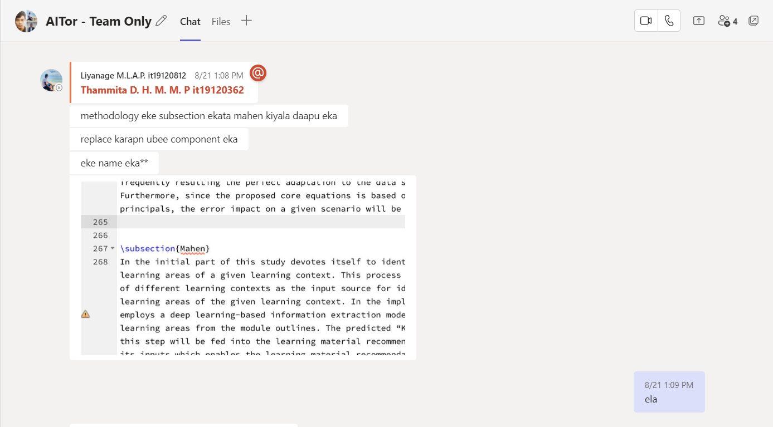

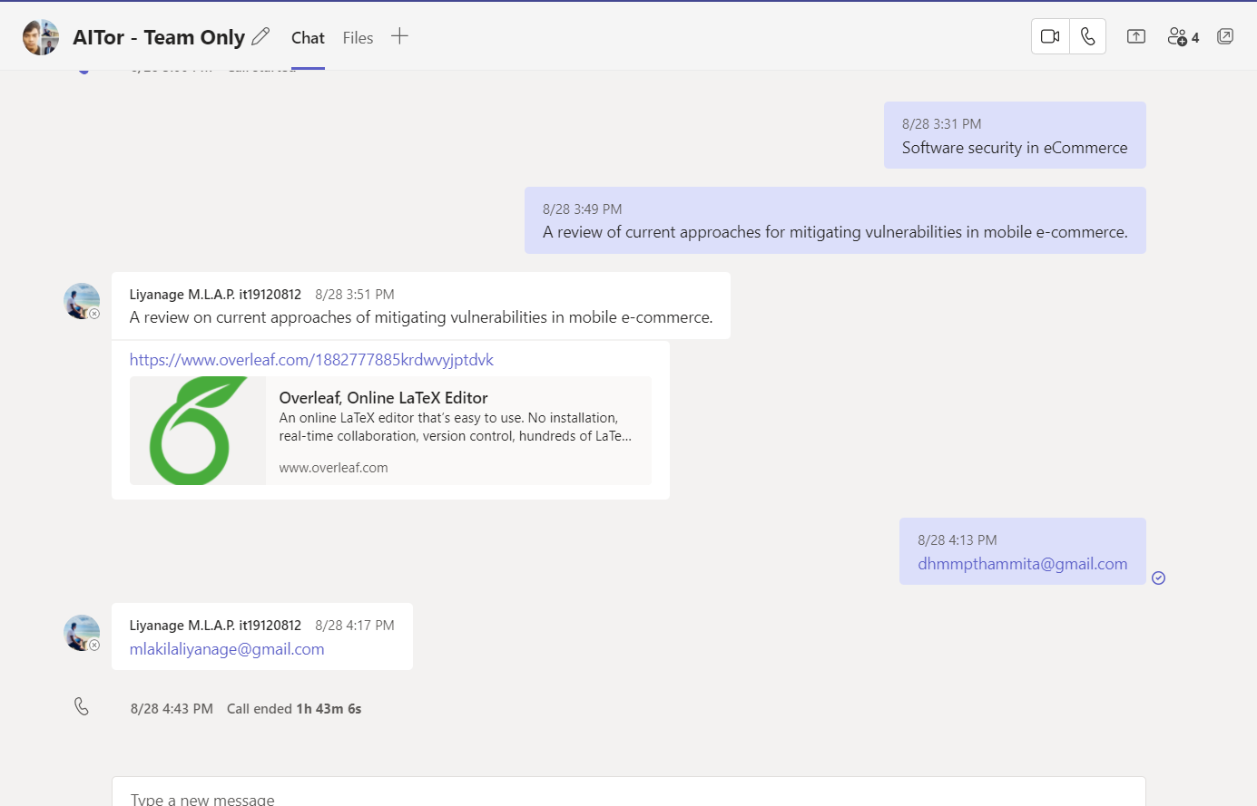

# WhatsApp Chat Group for Continuous Communication with Team Members with Supervisor/Co-Supervisor/External Supervisor.

## Continuous Commination through WhatsApp Chat Group

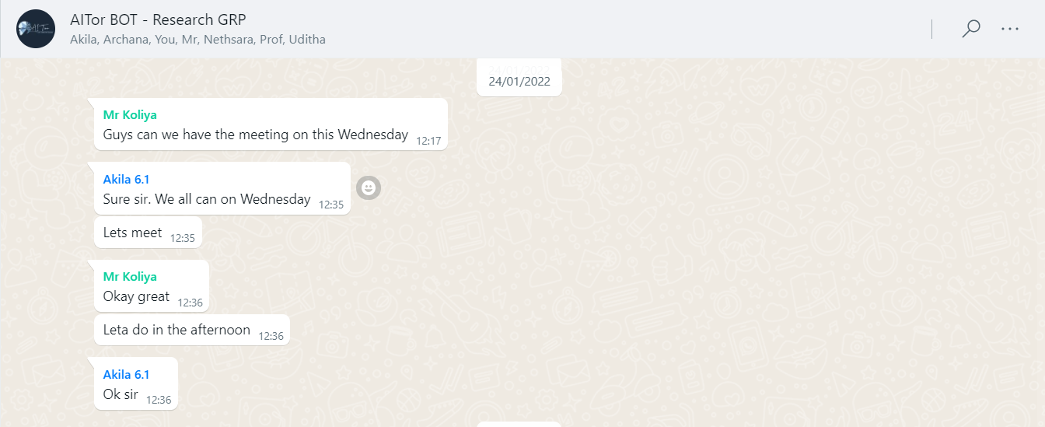

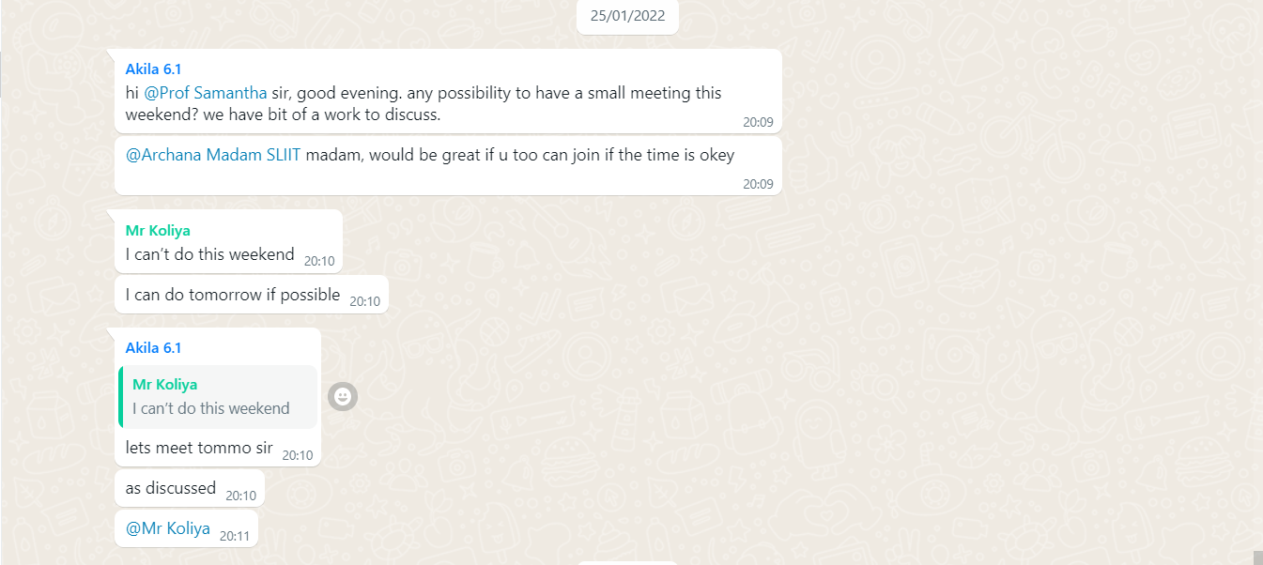

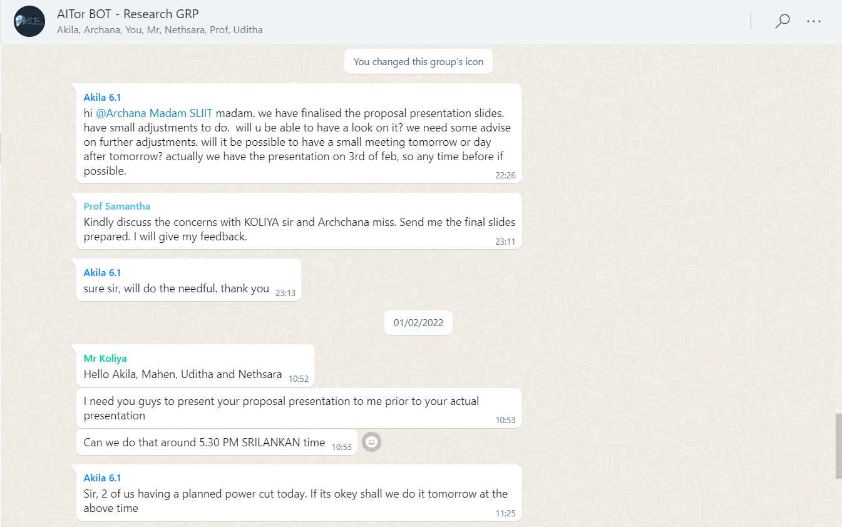

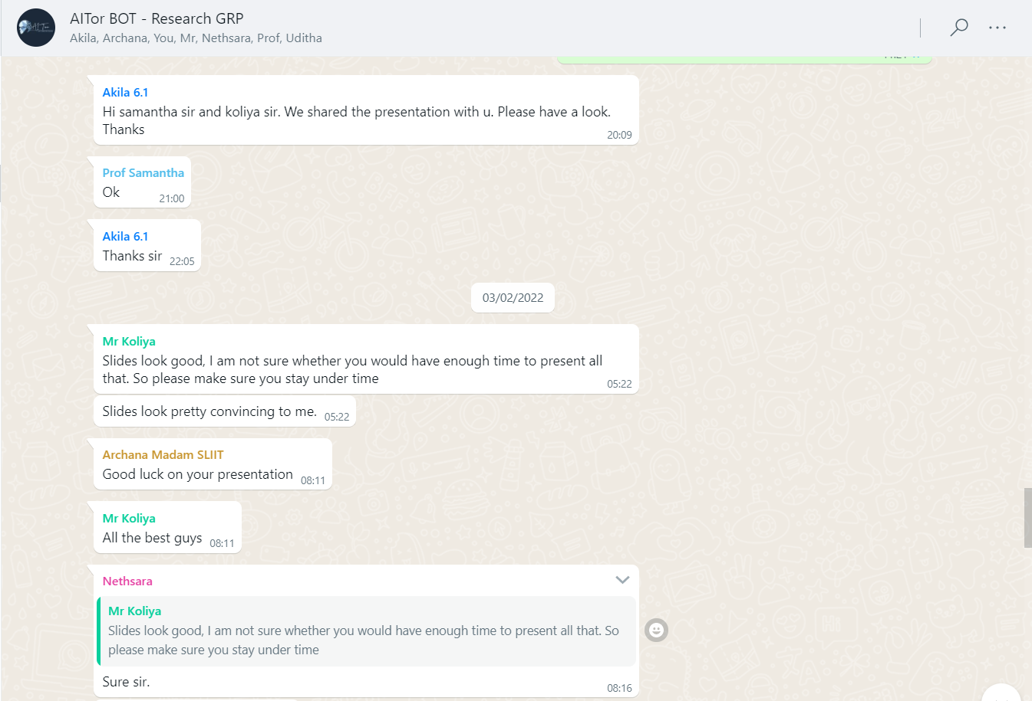

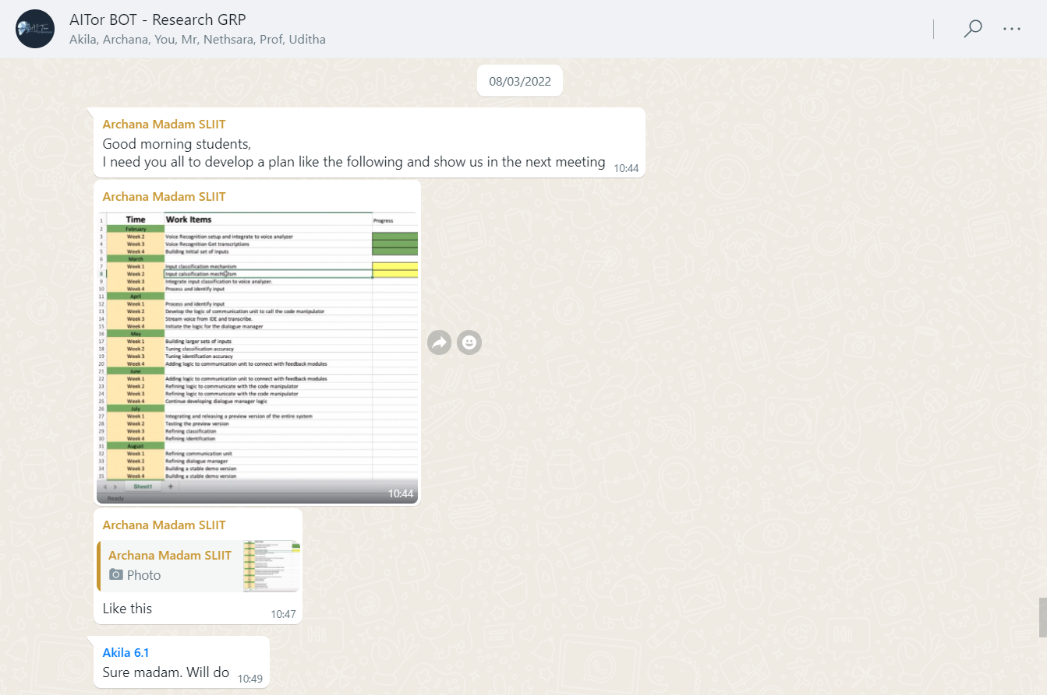

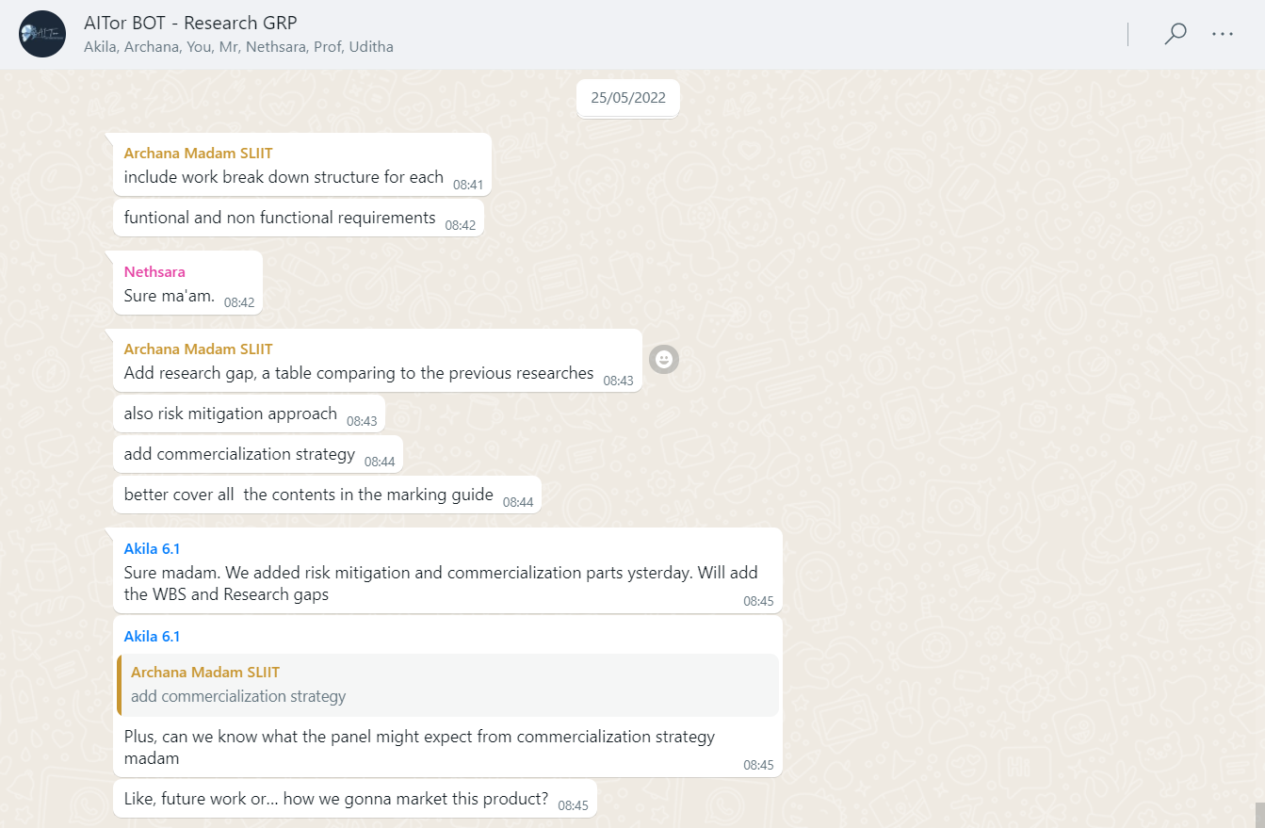

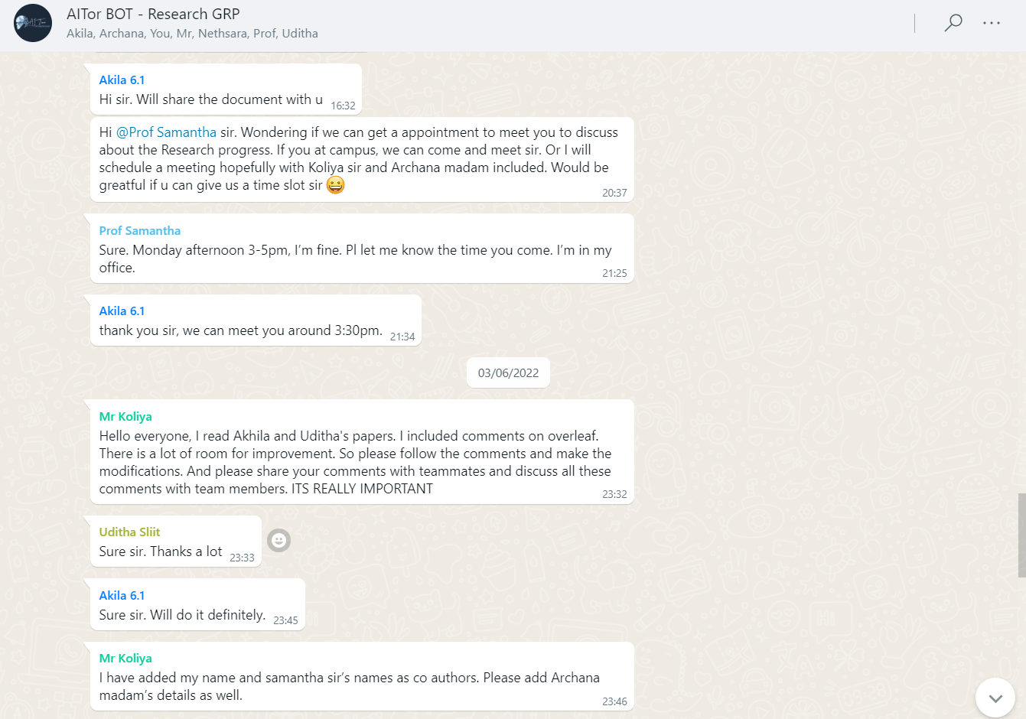

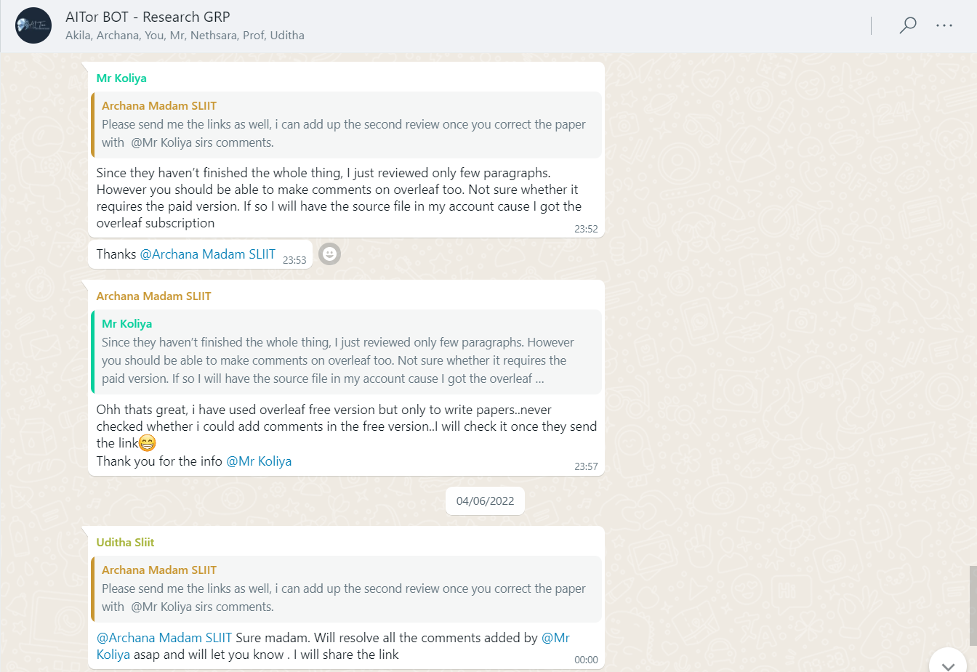

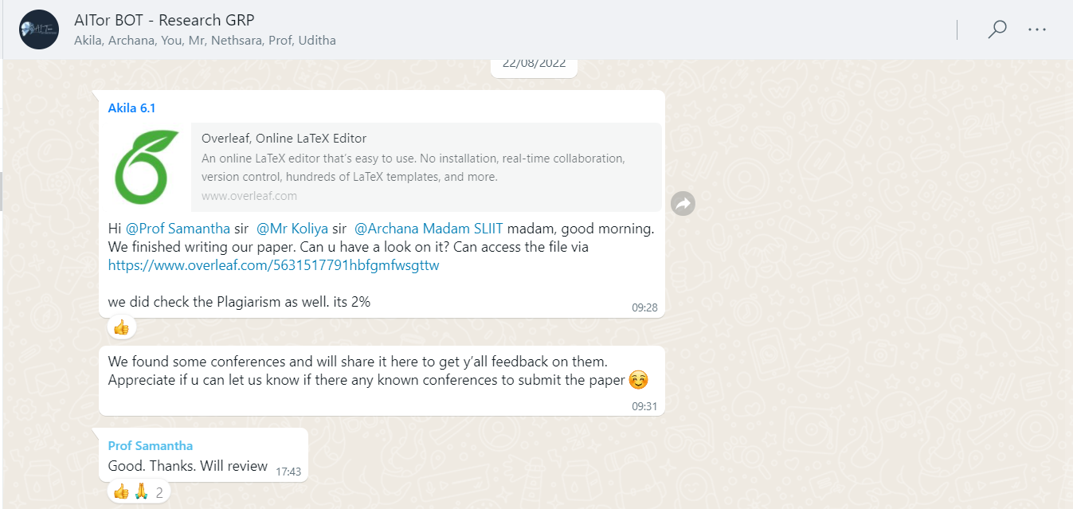

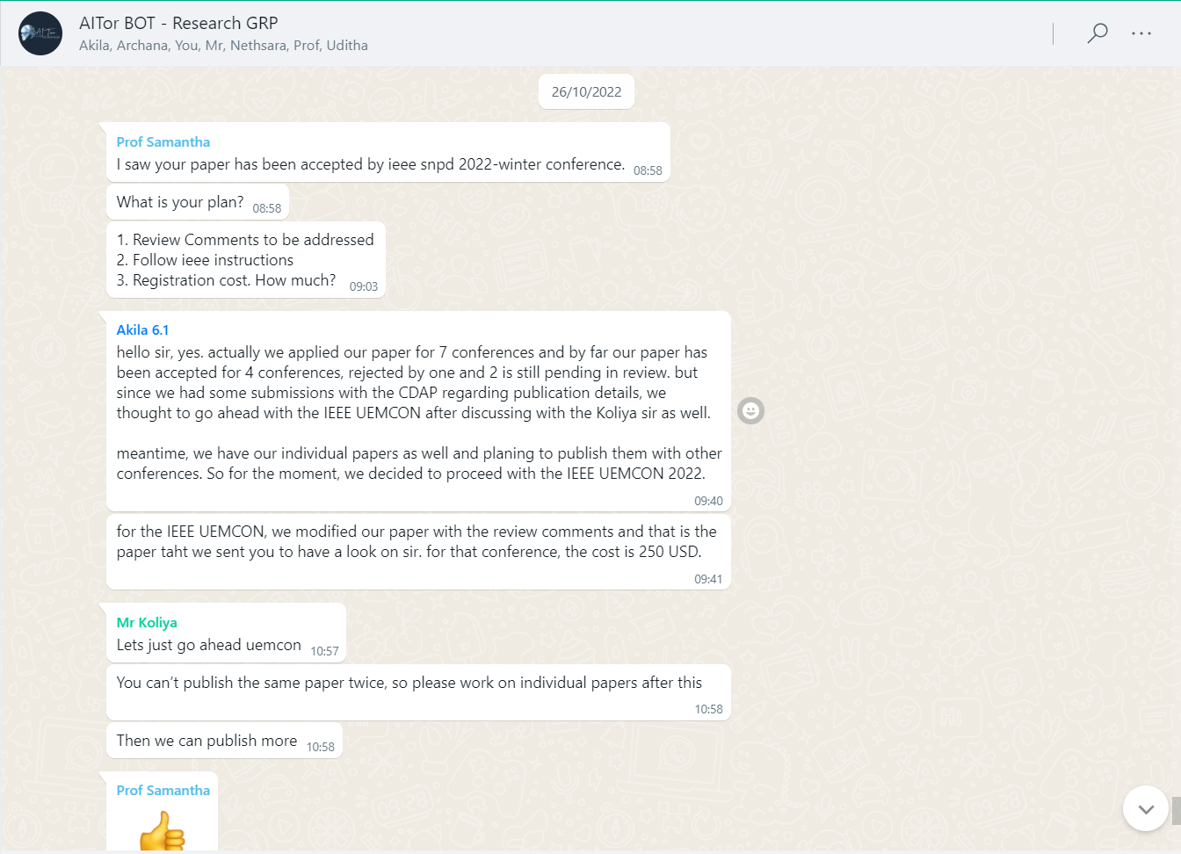

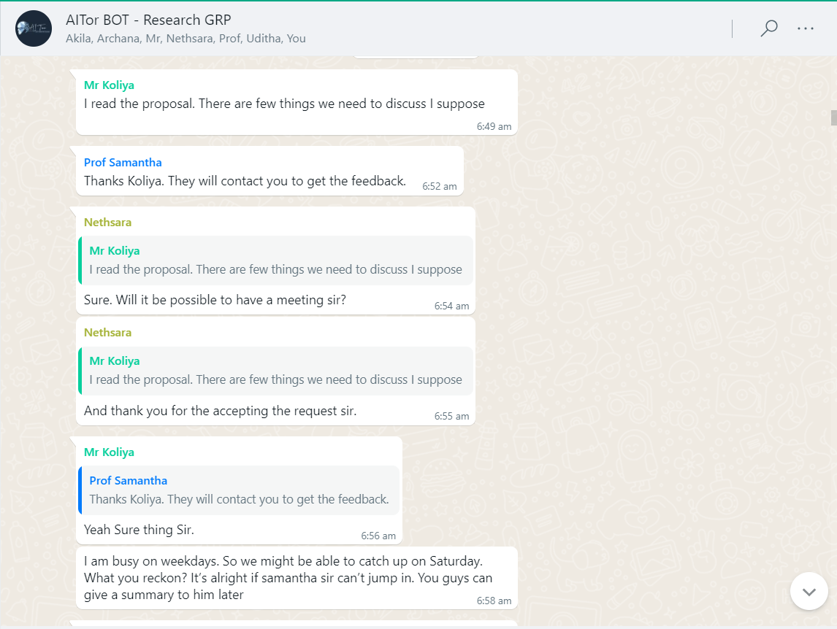

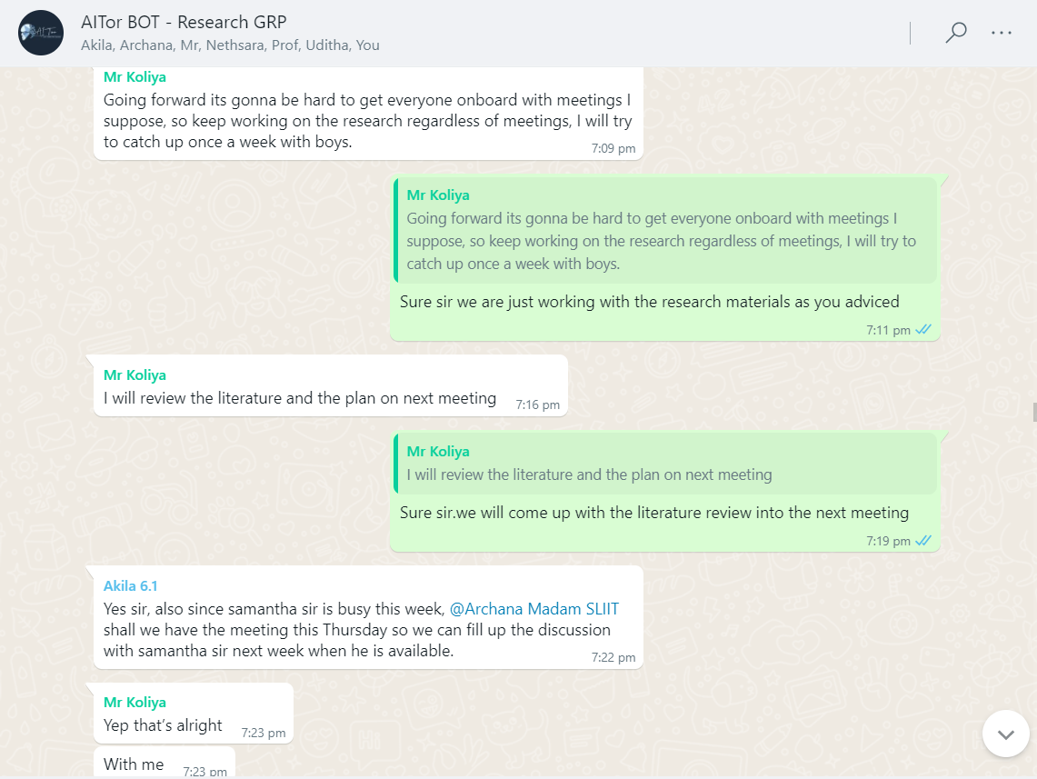

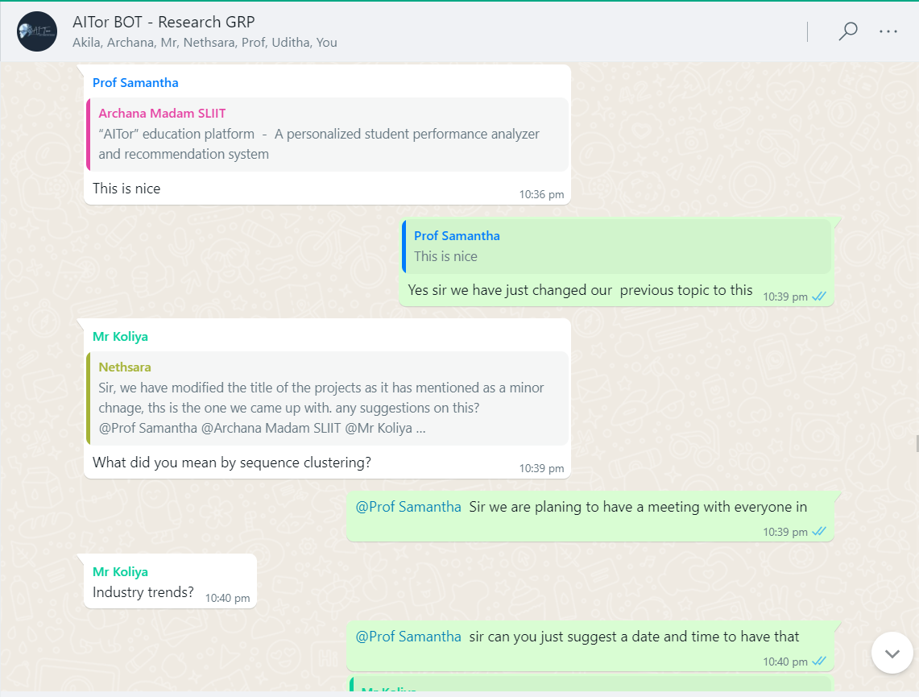

# Scheduled MS Teams discussions

## Weekly meeting with team members

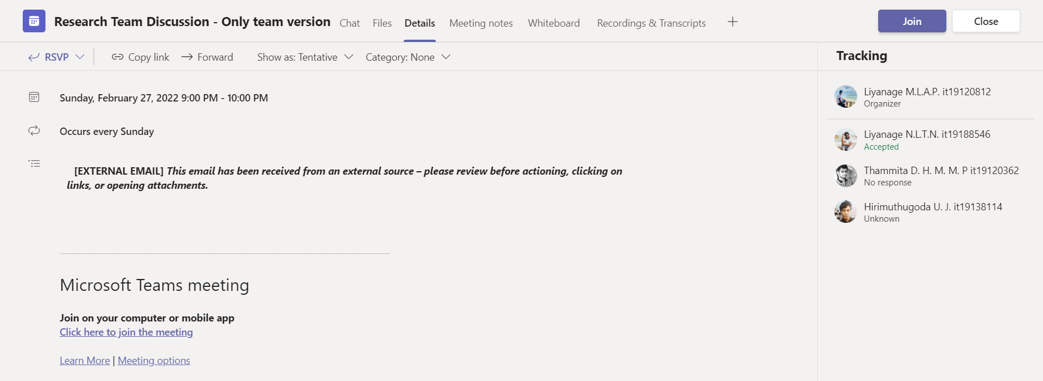

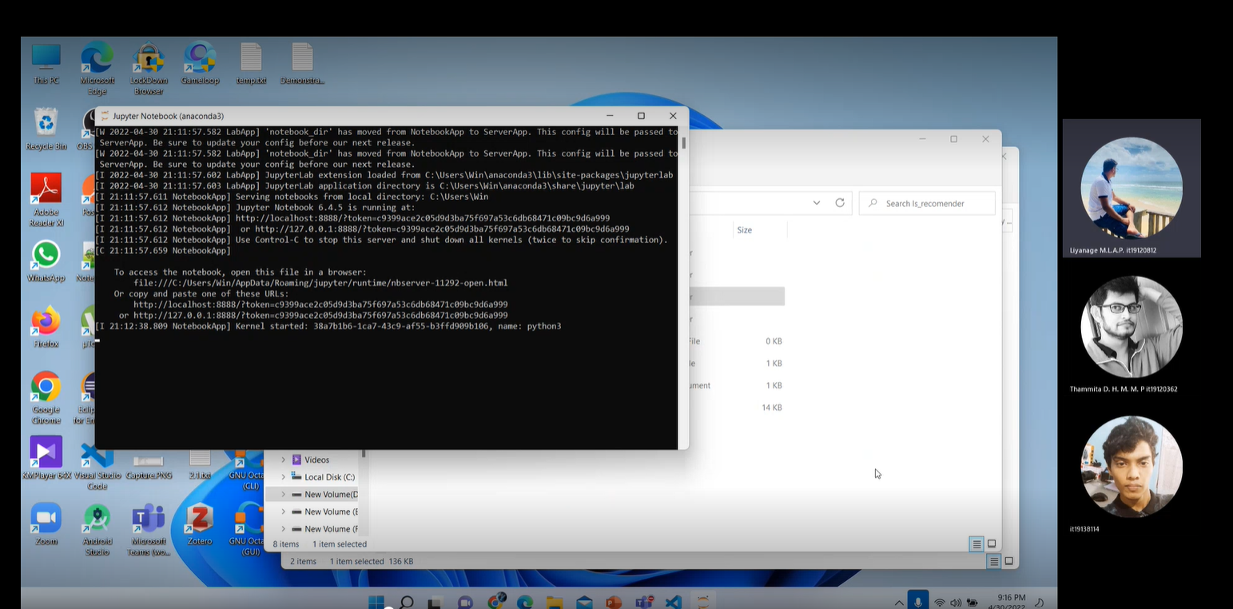

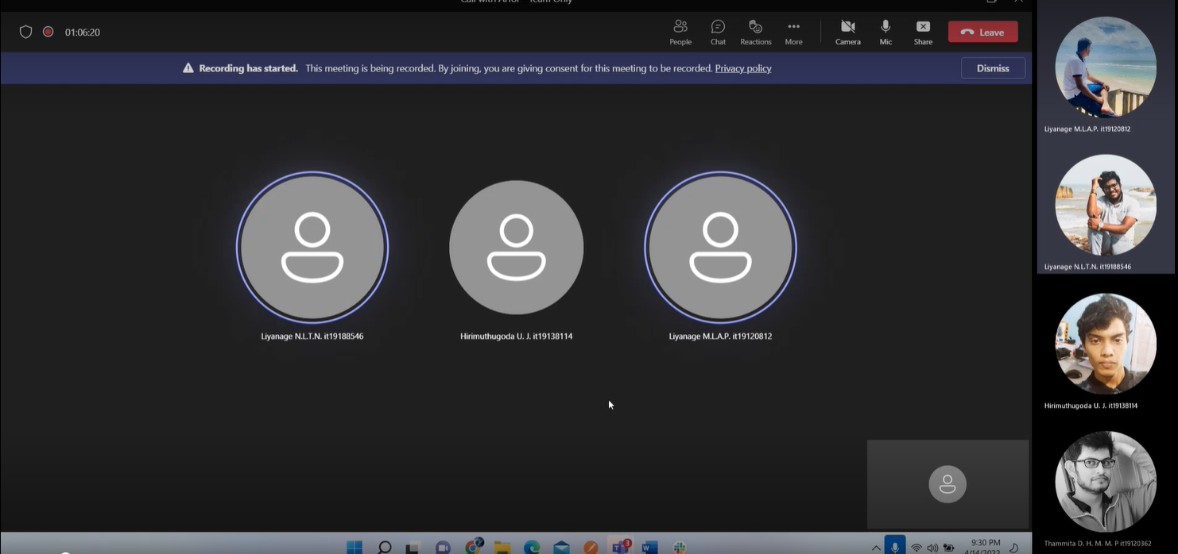

## Bi-Weekly meeting with Co-Supervisor/External-Supervisor for research progress evaluation

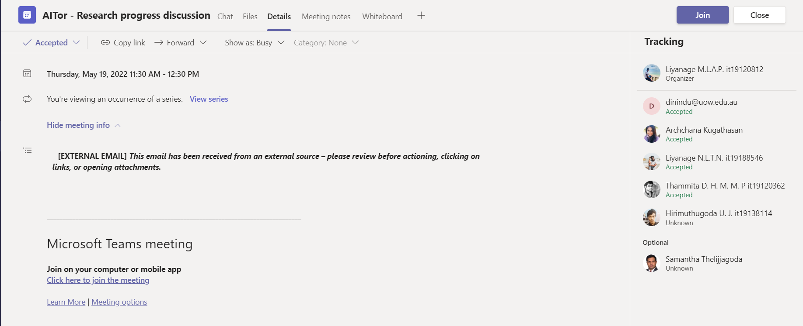

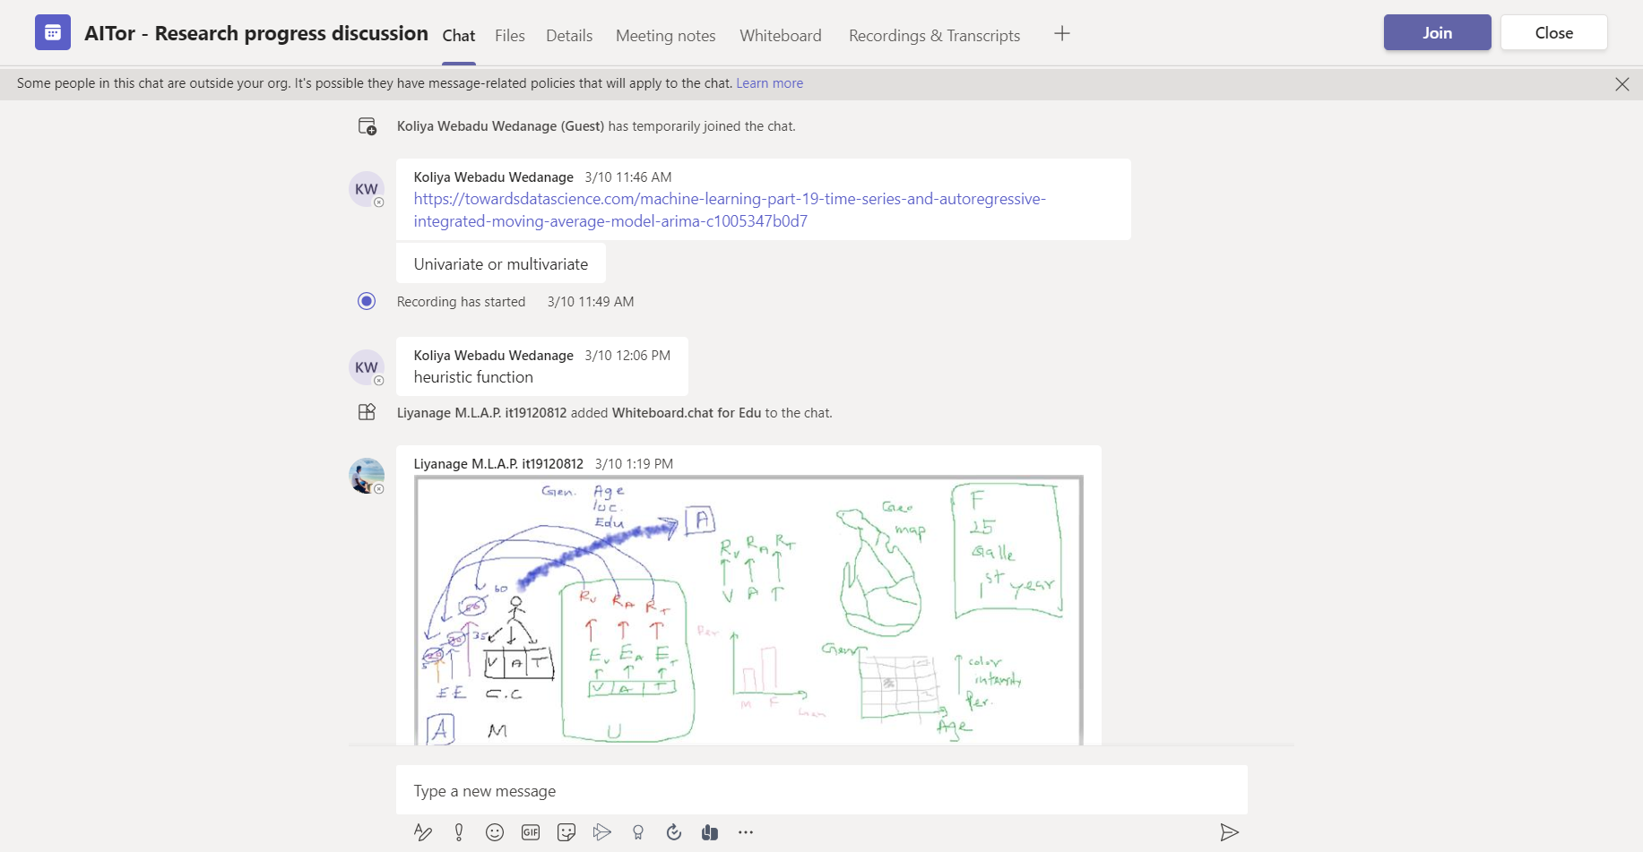

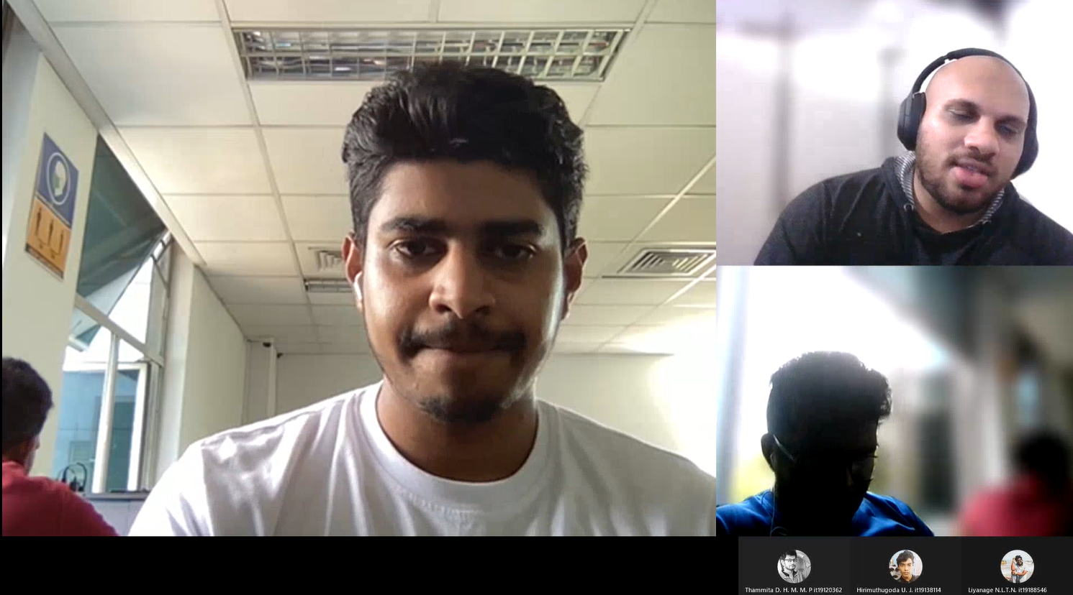

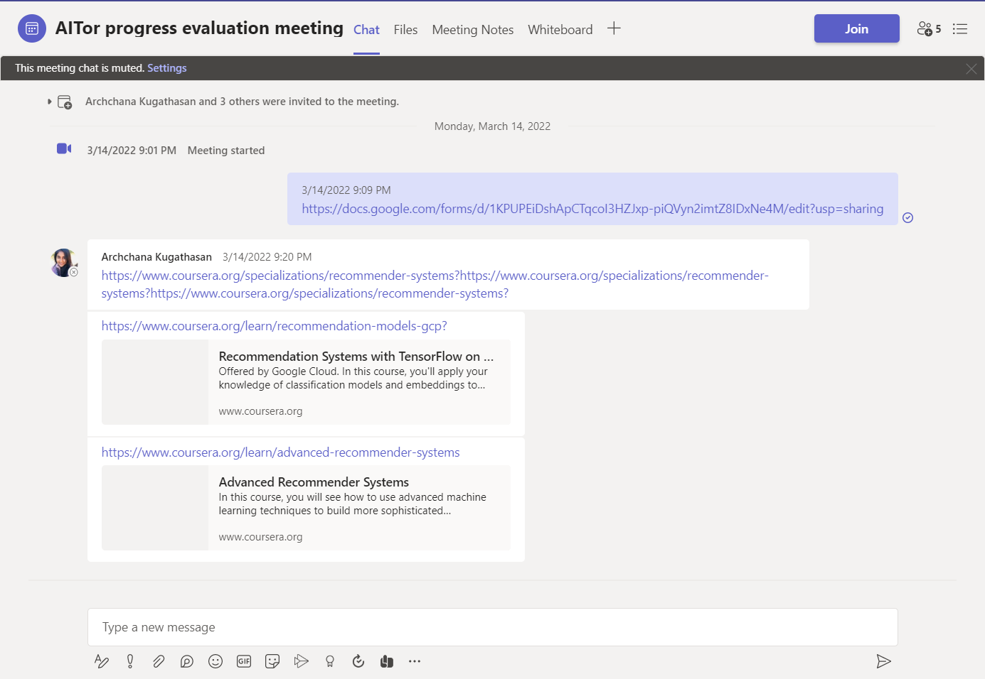

# Research Paper Presentations

## IEEE UEMCON 2022

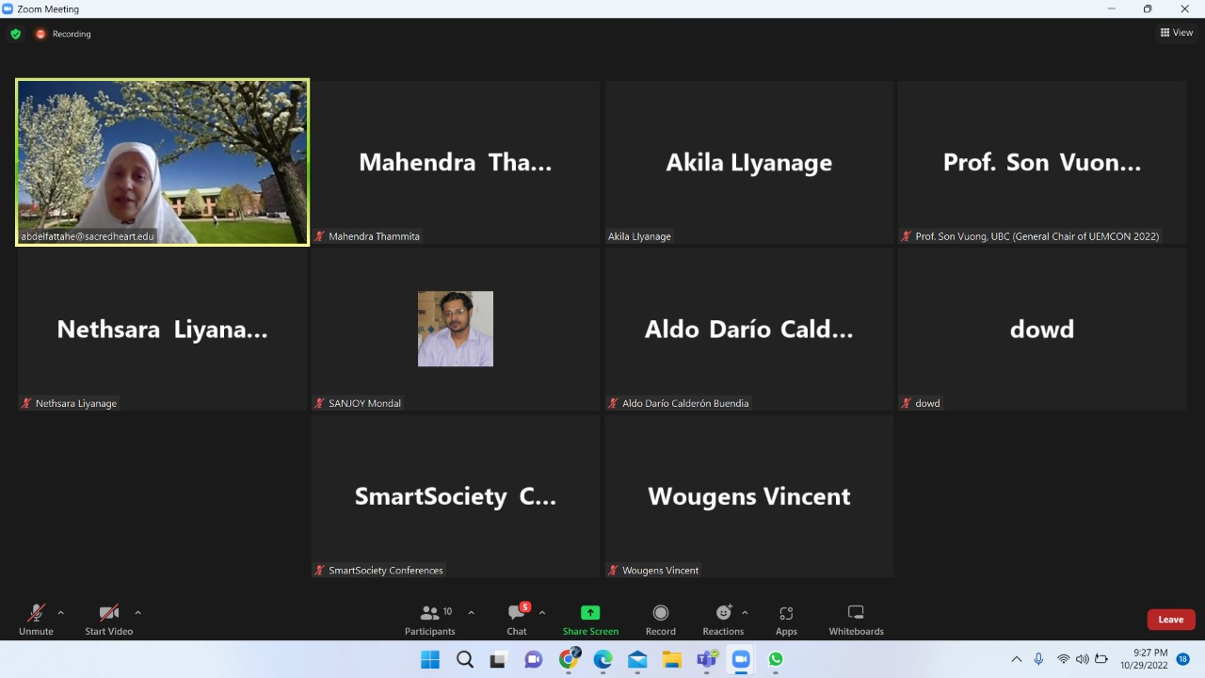

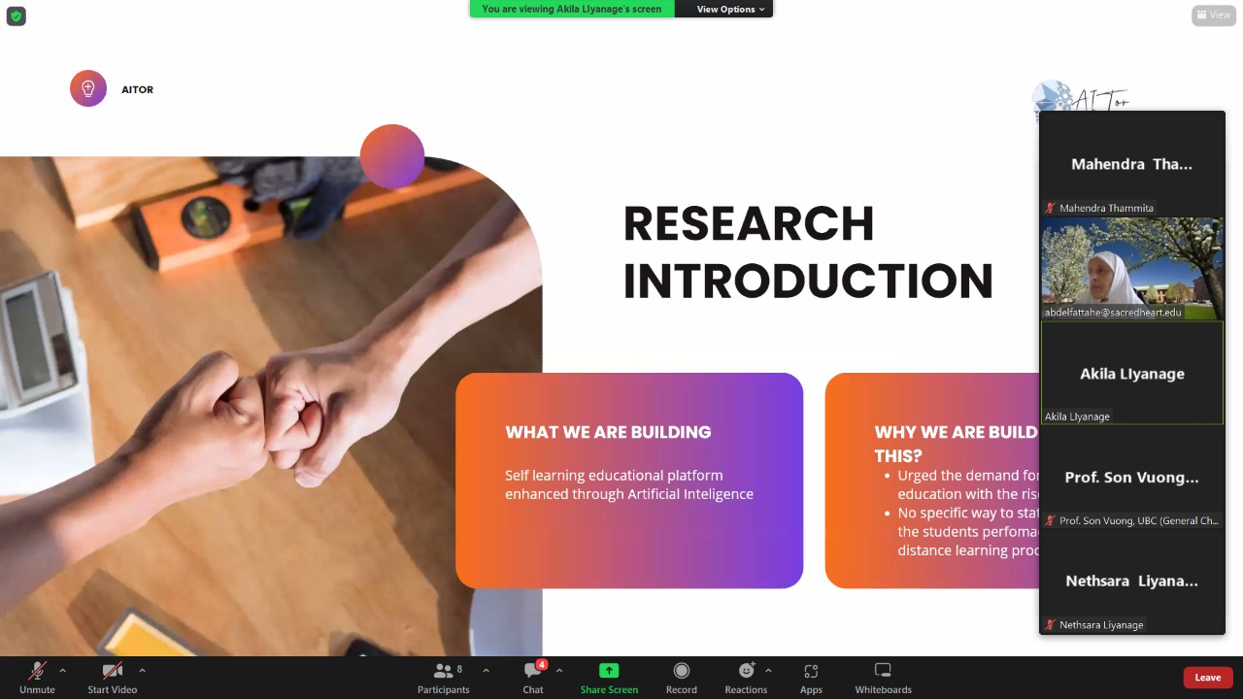

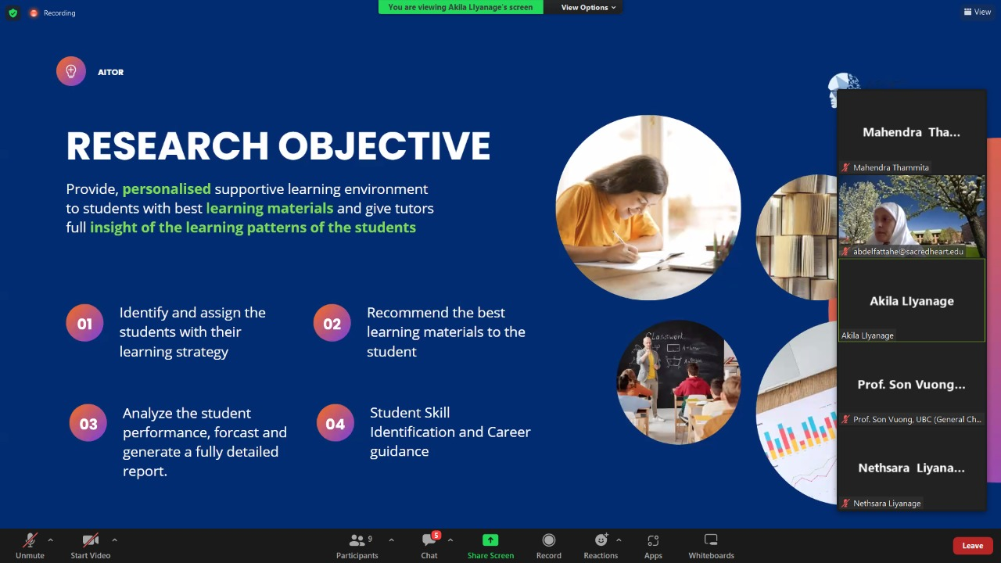

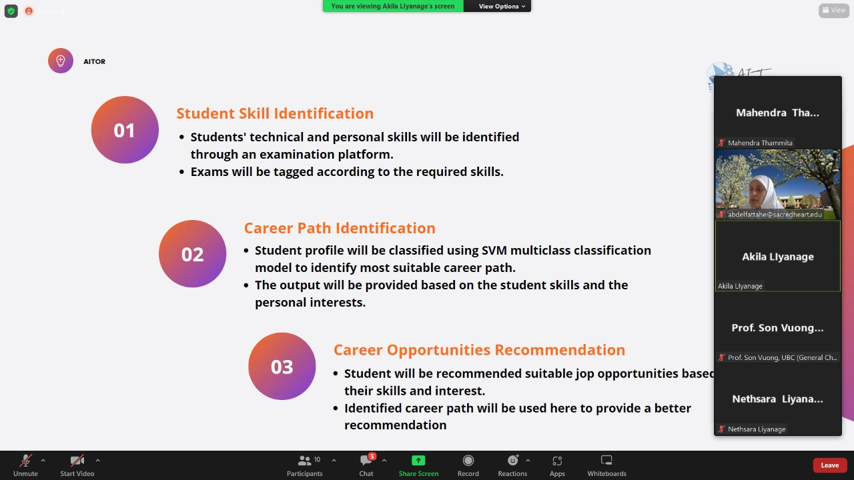

# Project planner

## Boards

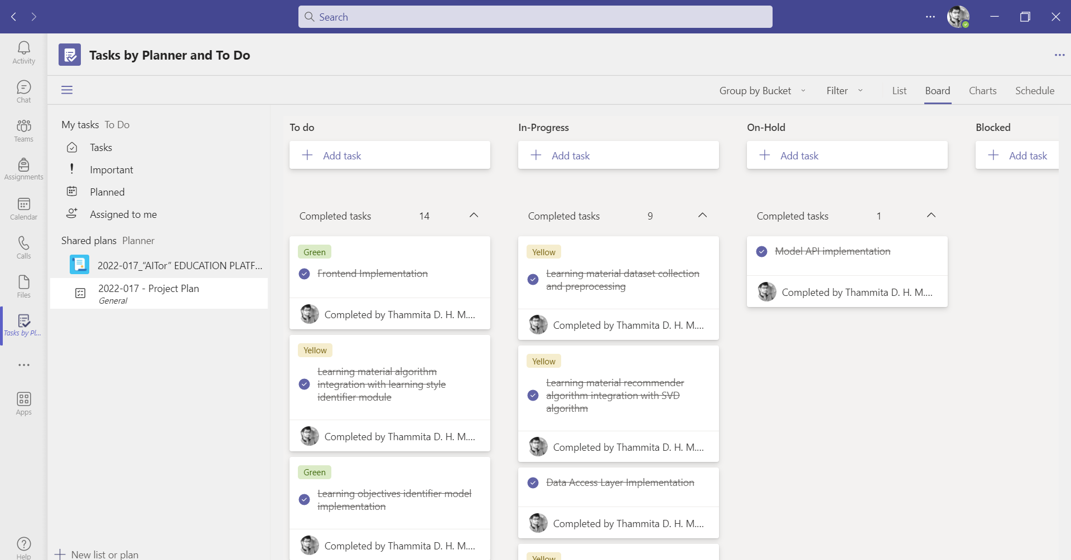

: Teams Planner Board : Grouped By Bucket

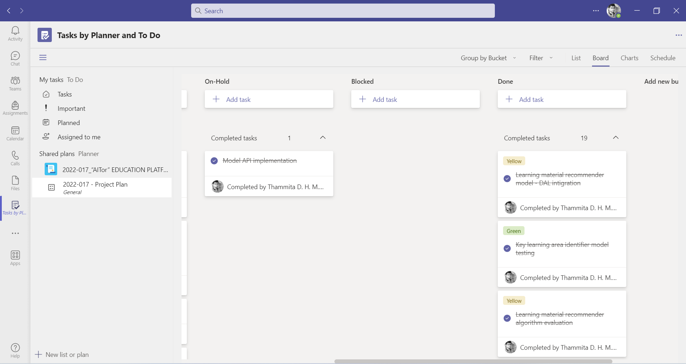

:Teams Planner Board : Grouped By Bucket - Completed

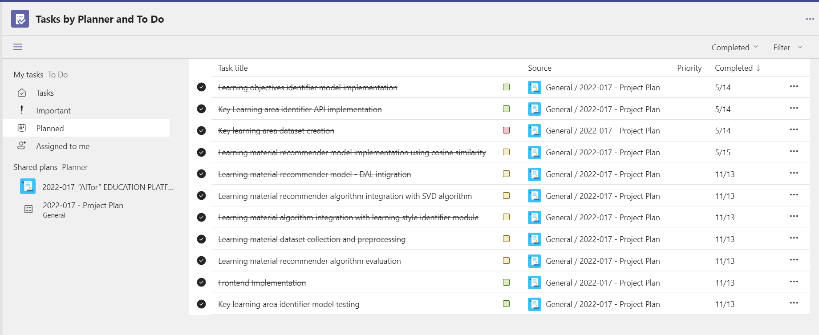

: Teams Planner Board : Completed Task List

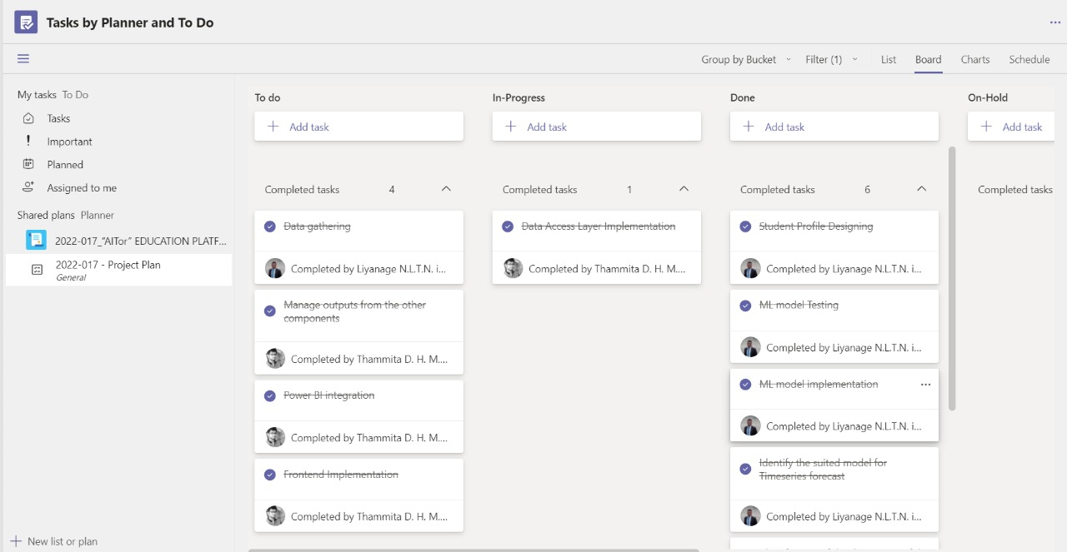

:Teams Planner Board : Completed Task List - Filter By Name

## Charts

### Overall Project Task Overview

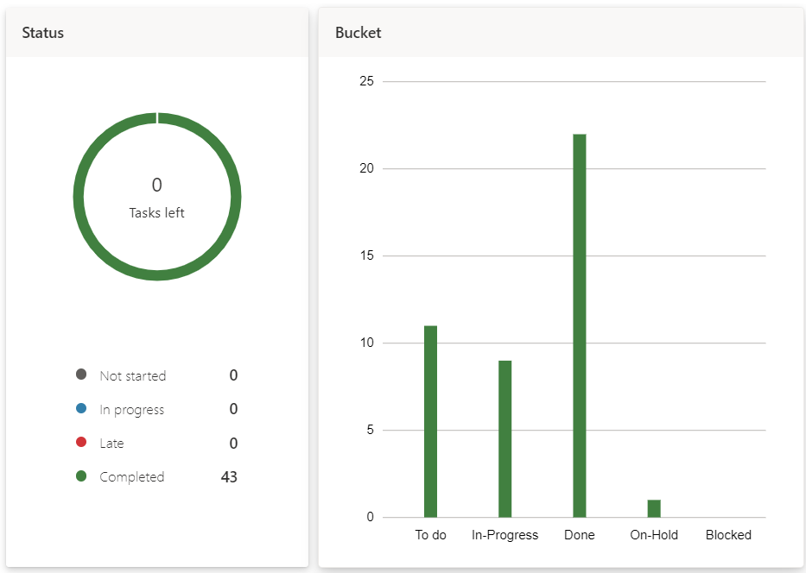

: Overall Project Task Overview - By Status and Bucket

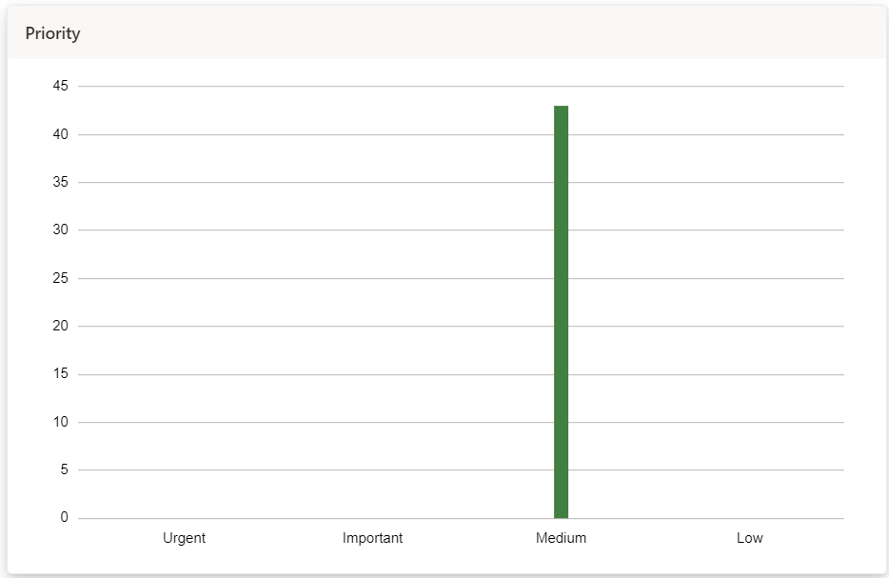

:Overall Project Task Overview - By Priority

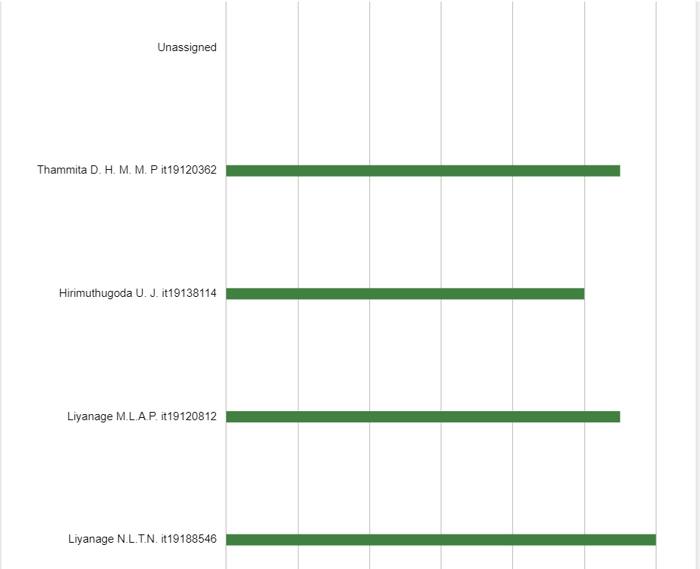

:Overall Project Task Overview - By Member

### Overview of Tasks of Liyanage M.L.A.P.(IT19120812)

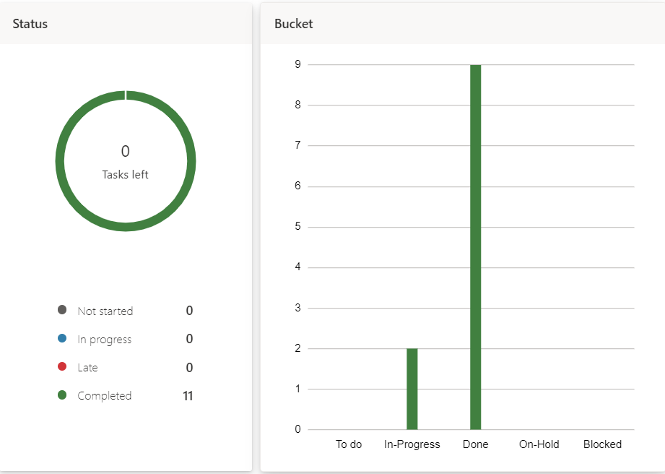

: 5.2.2. Overview of Tasks Of Liyanage M.L.A.P. (IT19120812) - By Status and Bucket

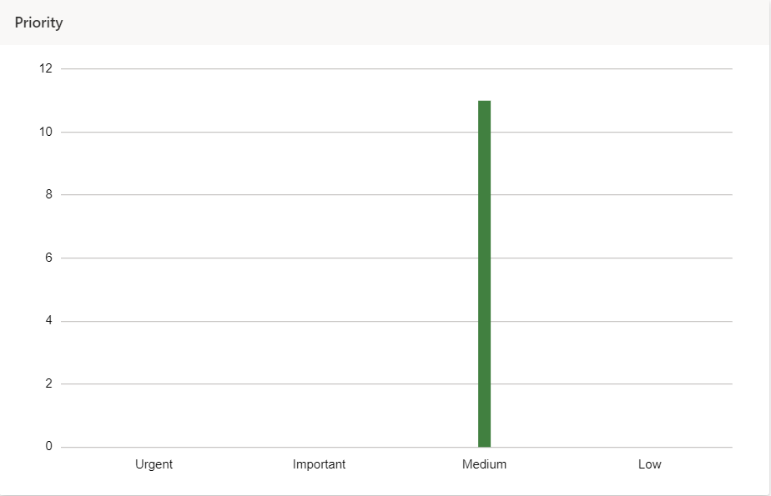

:Overview of Tasks Of Liyanage M.L.A.P. (IT19120812) - By Priority

# Project Gantt chart

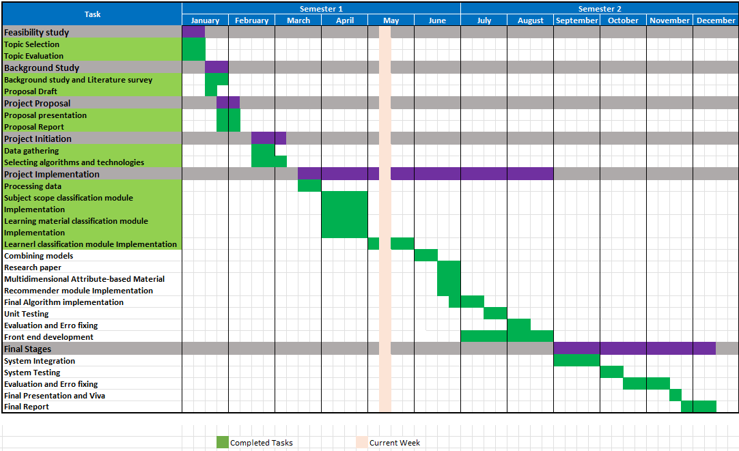

# Work breakdown chart

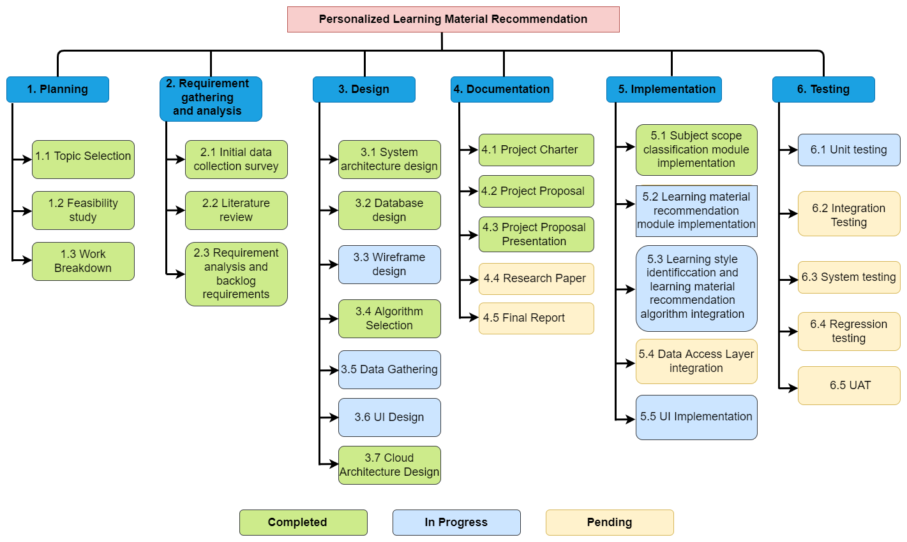

# User task allocation details

|  |  |  |
| --- | --- | --- |
| Allocated task | Predicted time | Actual time spent |
| Key learning area Identifier Dataset creation | 01/04/2022 – 30/04/2022 (30 days) | 20 days |
| Learning area Identifier algorithm implementation | 15/04/2022 – 30/04/2022 (15 days) | 21 days |
| Learning area Identifier API implementation | 01/05/2022 – 06/05/2022 (6 days) | 1 day |
| Learning material recommender model implementation using cosine similarity | 30/04/2022 – 11/05/2022 (11 days) | 6 days |
| Key learning area dataset creation | 05/04/2022 – 05/04/2022 (10 days) | 10 days |
| Learning material recommender model - DAL integration | 25/06/2022 – 30/06/2022 (5 days) | 2 days |
| Learning material algorithm integration with learning style identifier module | 30/06/2022 – 15/07/2022 (15 days) | 12days |
| Learning material dataset collection and preprocessing | 01/06/2022 – 01/07/2022 (30 days) | 30 days |
| Learning material recommender algorithm evaluation | 20/07/2022 – 31/07/2022 (21 days) | 25 days |
| Frontend Implementation | 15/07/2022 – 30/08/2022 (45 days) | 40 days |
| Key learning area identifier model testing | 15/08/2022 – 30/08/2022 (15 days) | 16 Days |
| Overall System Integration | 01/09/2022 – 20/09/2022 (20 days) | 30 days |

# GitLab Charts

## Commits To Master Branch

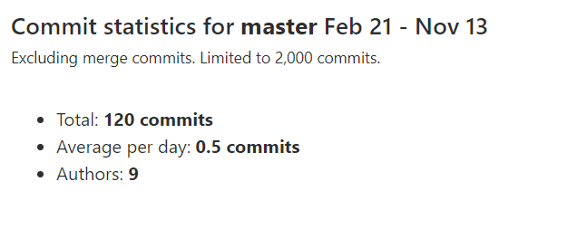

: Commit Statistics for Master Branch (Feb 21 - Nov 13)

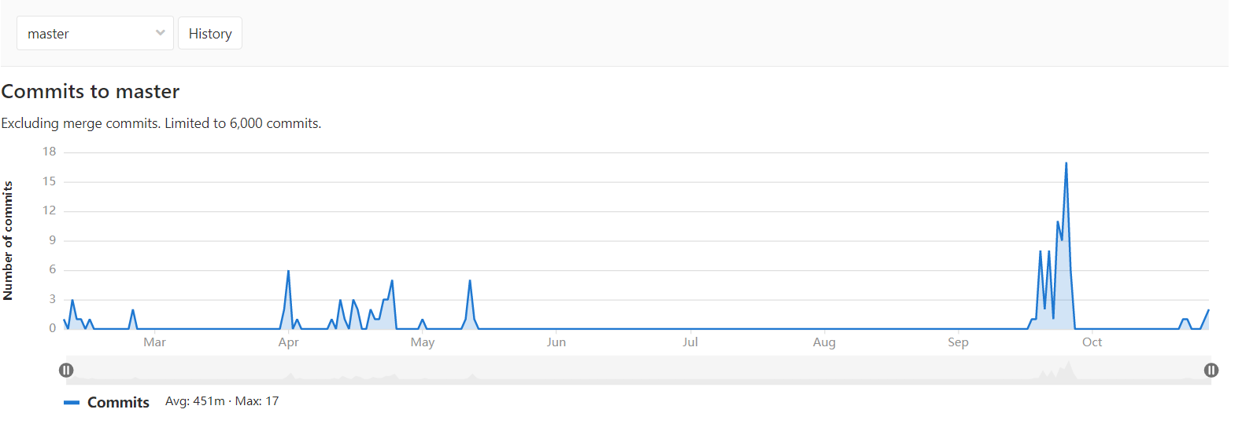

: Commits to Master Branch (Feb 21 - Nov 13)

## Commits By Liyanage M.L.A.P.(IT19120812)

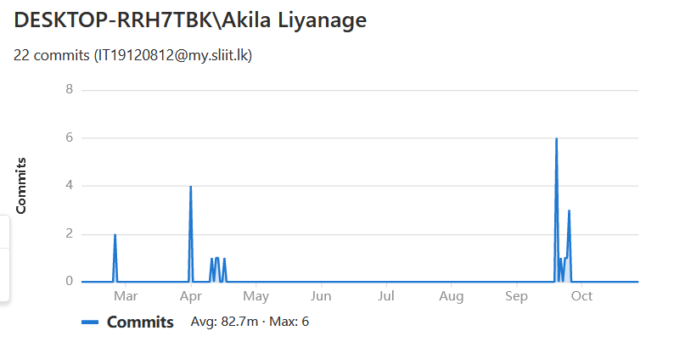

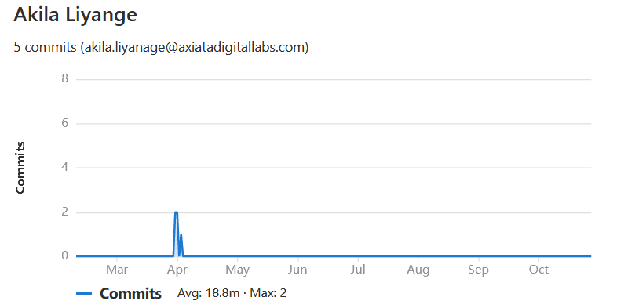

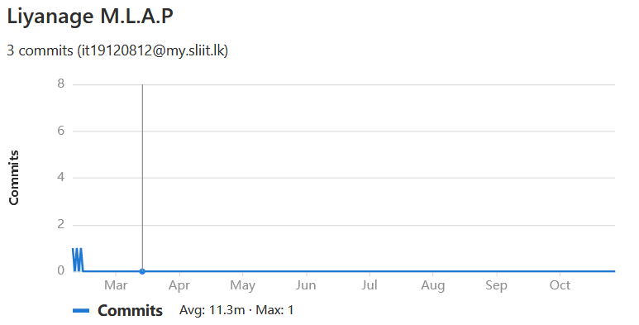

I have Used three user accounts were used to commit and screenshots commit charts of all user accounts are added in here

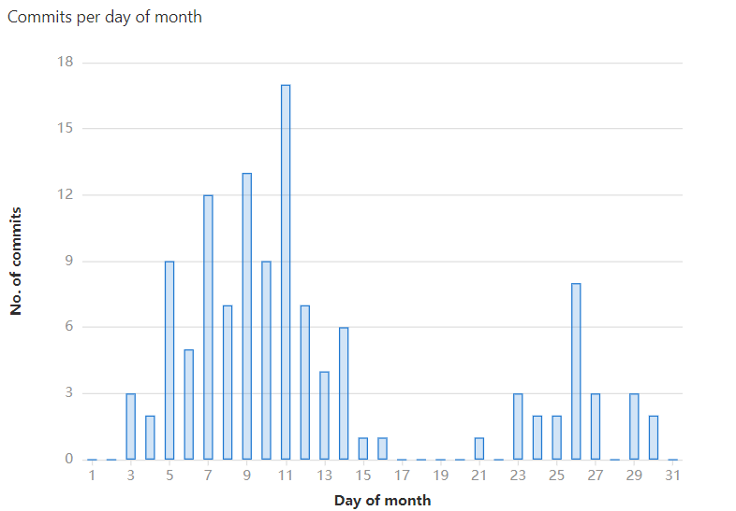

: 9:2 Commits Per Day of Month to Master Branch (Feb 21 - Nov 13)

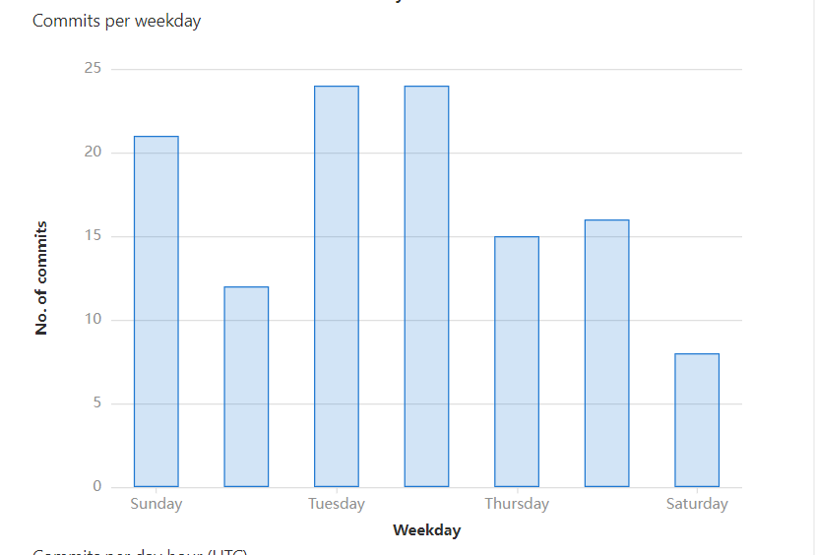

:Commits Per Weekday to Master Branch (Feb 21 - Nov 13)

## Commits To dev/it19120812

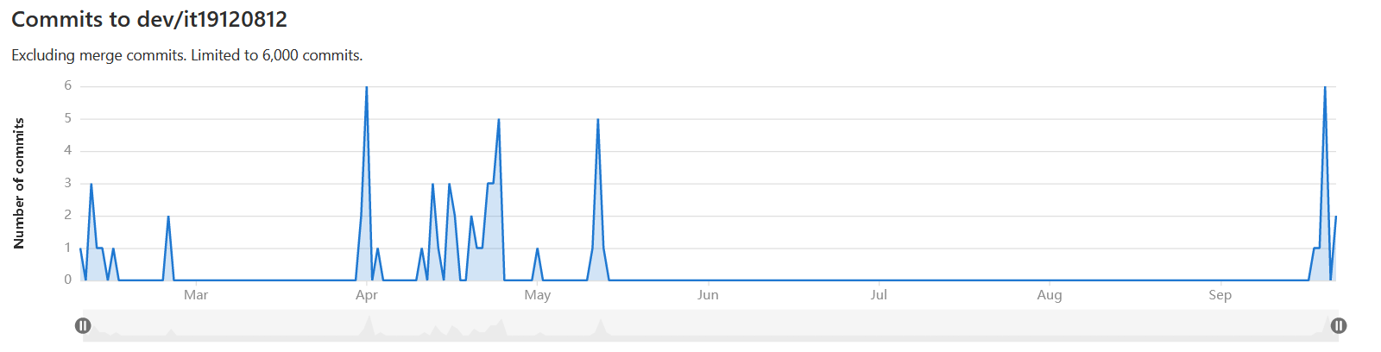

: Commits to dev/it19188546 Branch (Feb 21 - Nov 13)

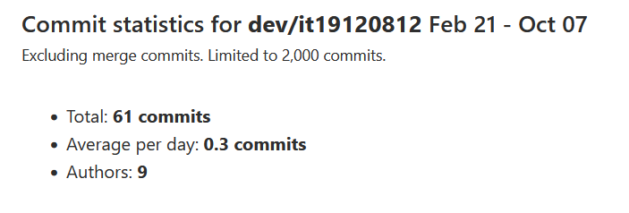

:9:3 Commits Statistics of dev/it19188546 Branch (Feb 21 - Nov 13)